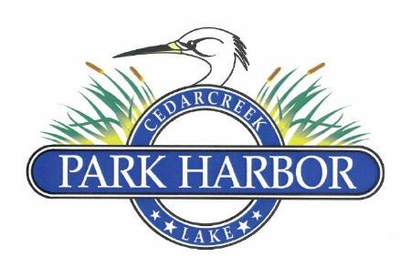

19 NOVEMBER 2022

PARK HARBOR ANNUAL MEMBERS MEETING MINUTES

1. Dan Prather called the meeting to order at 10:00AM
2. Attendees were welcomed and the 2022 Board of Directors was introduced
3. Eddie Miller conducted a member rollcall and determined that a quorum of eligible members was present
4. The ballots for the election of Directors and the approval of the 2022 proposed Amended and Restated Bylaws of the Park Harbor Property Owners Association were collected and turned over to Carol Mayo of the Election Committee
5. Roddy Cummins handed out copies of the current balance sheet and income statement then presented a recap of expenses for the 12 months ending 10/31/22
6. Dan Prather welcomed the new members for 2022 (Natalie and Eddie Miller)
7. Dan Prather gave an update on 2022 major accomplishments and discussed in particular the 2022 Amended & Restated Bylaws along with the rebuild and improvement of the dock area
8. Eddie Miller introduced the new POA website – parkharborpoa.com, and discussed some of the upcoming board projects such as the Dry Fire Hydrants, and constructing a cover for the mail boxes.
9. Randy Delana gave a report on the Property Management Committee that included a reminder of the new front gate combinations, two upcoming drainage projects under consideration and future road repairs
10. Charlene Mason gave a reminder of the Chili Cookoff at 6:30 this evening and gave a report on the 2022 July 4th Parade.
11. Jim Barrett and Randy Delana were recognized for their outstanding work on the Dock / Park project and were presented with mementos stating same
12. Carol Mayo gave the elections results for the 2022 Amended and Restated Bylaws: approve = 23 votes, abstain = 1 vote and against = 0 votes. The new 2022 Amended and Restated Bylaws officially passed to the applause of the gathered members
13. Dan Prather presided over the ribbon cutting ceremony officially opening the new dock and park area where both Jim Barrett and Randy Delana cut the red ribbon
14. Carol Mayo announced the Board of Directors election results where Roddy Cummins, Randy Delana, David Gould and Eddie Miller were elected to 2 (two) year terms
15. There being no further business, Dan Prather adjourned the meeting