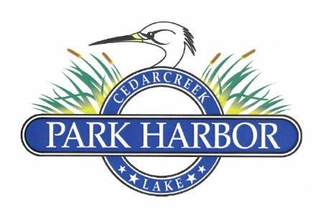

19 NOVEMBER 2022

PARK HARBOR POA BOARD OF DIRECTORS MEETING MINUTES

1. Dan Prather called the meeting to order at 11:32 AM
2. Directors present were: Dan Prather, Charlene Mason, Roddy Cummins, Randy Delana, David Prevost and Eddie Miller
3. The Board moved into Executive Session to hear from a Member regarding their recent unsatisfactory experiences with building contractors working on an adjacent property to their home. After discussion, the Member departed the meeting and Dan moved the Board back into regular session.
4. For some lengthy period, Mr. Houde has been attempting to resolve a shortage of outside storage space at his lakeside property. While a number of options have been forwarded to the ARC, each one has not satisfied all parties. In September, the ARC requested the Board of Directors consider a possible solution involving a CCR variance. The Board considered the request and determined that a decision at that time would be premature pending the possibility of a new slate of Directors being elected in November. Thus, the ARC and Mr. Houde were advised of that decision. At this meeting (November 19th) of the newly constructed Board, the property modification application by Mr. Houde and the ARC’s position were discussed at length. Ultimately, no vote was taken on the ARC’s request for a variance to the CCRs. Instead, it was determined that Eddie Miller would contact Mr. Houde and discuss possible resolutions to the issue that would satisfy his need for storage, comply with the current CCRs, and result in the relocation of an existing structure that will comply with all right of way and setback restrictions. If those discussions are profitable, Mr. Houde would submit a new application to the ARC to receive all approvals and necessary permits.
5. Roddy presented a detailed review of the 2023 POA budget and after discussion, this budget was approved by a unanimous vote.
6. Roddy presented a recommended pricing policy to charge a Transfer Fee of $100.00 and a Resale Certificate Fee of $375. After discussion and a review of pricing structures of other POAs in Henderson County, Roddy’s recommendation was approved by a vote of 5 (five) for and 1 (one) against.
7. Roddy reviewed the POA’s current General Liability and D & O insurance policies. This was received by the Board as an informational report.
8. Dan appointed with the Board’s unanimous approval, the following 2023 committee members
   1. Property Management Committee – Randy Delana and Jim Barrett
   2. Property Security Committee – David Prevost, David Gould and Chris Nichols
9. 2023 Board of Directors officers were then discussed and the following individuals were unanimously elected:
   1. Dan Prather – President
   2. Charlene Mason – Vice-President
   3. Roddy Cummins – Treasurer
   4. Eddie Miller – Secretary
10. Muddy Moxley was asked to submit her request for a gas fireplace propane tank to the ARC for approval.
11. Roddy then requested that the Board approve a new resolution to designate the following Board officers with checking account signing authority: Dan Prather, Charlene Mason and Roddy Cummins. This request passed by unanimous consent.
12. There being no further business, Dan adjourned the meeting at 1:10 PM.