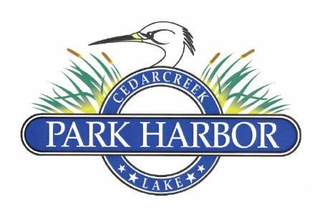

29 January 2023

PARK HARBOR POA BOARD OF DIRECTORS MEETING MINUTES

1. Dan Prather called the meeting to order at 3:02 PM
2. Directors present were: Dan Prather, Charlene Mason, Roddy Cummins, Randy Delana, David Prevost, David Gould and Eddie Miller
3. Dan welcomed our new Board member, David Gould
4. Board unanimously approved the 10.2.22 regular Board meeting minutes
5. Board unanimously approved the 11.19.22 annual meeting minutes
6. Board unanimously approved the 11.19.22 regular Board meeting minutes
7. Roddy gave the treasurer’s report that included both the income statement and the balance sheet. He further explained the functions of the new Financial Review Committee and indicated that they have already begun the review of 2022 records.
8. Dan led the Board in a review of the new proposed 2023 ARC Charter. After discussion, which resulted in the language change to clarify and extend the definition of improvements to include maintenance and repairs, the Charter was approved unanimously.
9. Dan led the Board in a review of the proposed 2023 ARC Application. After discussion, which resulted in the rewording of Item 10 in the Construction Conditions & Requirements section, the Application was approved unanimously.
10. Charlene proposed that Jim Gray be appointed to the ARC committee to replace Mike Greenwood. After a brief discussion, this appointment was approved unanimously. Dan crafted a welcoming letter which has been sent to Jim.
11. Eddie gave a report on a request received by a non-member for POA access. After discussion, it was decided that the proposed plan did not meet the POA’s requirements and there would be no action taken at this time.
12. Eddie gave a report on the initiative to transfer the front fence easement to the POA. After discussion, the Board approved this project and instructed Eddie to contact an attorney to get an estimate on the cost of the supporting legal documents.
13. Eddie gave a status report on the Dry Hydrant project which included elevations, diagrams, initial hardware and proposed vendor. The Board agreed that Eddie should continue developing the plan for this project and present a final plan/budget to the Board for approval prior to incurring any costs.
14. Eddie gave an update on the Lakeshore Water Utility District’s future plans to refurbish / update their well and pump station located on the POA property.
15. Eddie gave a report on the idea of changing the access to the boat ramp / dock area from a combination lock to keyed access with every member receiving a key. The Board agreed to discuss the project further after a cost estimate was received. Chris Nichols is in contact with a vendor that will supply this estimate.
16. Eddie informed the Board of the Lakeside Development’s plans to contact the county and see if they would be amenable to cutting the trees and underbrush on the road right of way against the fence of the horse farm property.
17. Dan moved the Board into executive session to discuss a fence encroachment on the POA property by a member. After discussion on this topic, the Board moved back into regular session.
18. Dan set the next regular Board meeting for Sunday, April 23rd at his residence. The meeting will start at 3:00PM.
19. There being no further business, Dan adjourned the meeting at 5:05PM.