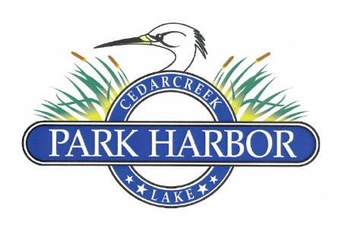

13 August 2023

PARK HARBOR POA BOARD OF DIRECTORS COORDINATION MEETING MINUTES

Dan Prather called the meeting to order at 4:35PM.

Directors present were: Charlene Mason, Dan Prather, Roddy Cummins, Randy Delana, David Gould, Davis Prevost and Eddie Miller.

The Board unanimously approved the 7.30.23 Board coordination meeting minutes.

Roddy reported that as our 3-year QuickBooks subscription had expired and a $600-$800 renewal was prohibitive, we would not be able to offer automatic (monthly, quarterly or semi-annually) payment plans to members. However, in case of hardship, the Board agreed to provide a semiannual payment schedule that would be processed manually.

Roddy reviewed the Proposed 6th Amended and Restated CCR edits made within the past week:

Added definition for Inoperable Equipment to Article 1

Edited language for Variances in 3.5

Edited language for ARC in 4.4

Edited language for Fences in 4.8

Edited language for Parking/Storage of Vehicles, Boats, and Equipment in 4.14

Edited language for Regular Assessments in 5.1

After discussion, the Board unanimously agreed to approve the Proposed Sixth Amended and Restated CCRs as edited for distribution to the general membership.

Roddy reviewed the Information Packet that would accompany the Proposed CCRs for distribution to the general membership. The Board approved the document as presented.

Eddie reviewed the “Timeline” for Board activities preceding the General Membership meeting in November and changes were approved to move up several dates.

Eddie reviewed the idea of allowing the Eustace and Payne Springs Fire Departments to utilize the POA’s boat ramp for water access not only for Park Harbor fires, but also for local area fires where it made tactical sense to do so. After discussion, the Board agreed to that idea and Eddie will contact both Fire Chiefs to inform them of their new water source.

Dan adjourned the meeting at 5:55 PM.