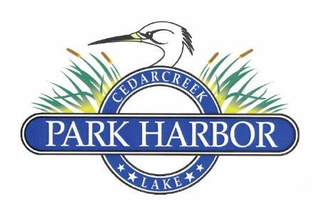

18 NOVEMBER 2023

PARK HARBOR POA ANNUAL MEMBERS MEETING Minutes

1. Charlene Mason called the meeting to order at 10:05 and welcomed the attendees
2. Eddie Miller conducted a Member roll call and confirmed that there was a quorum of eligible Members present to conduct elections and business
3. Eddie Miller collected all the ballots for the election of 2023 Board of Directors and the 6th Amended and Restated Conditions, Covenants and Restriction elections then turned them over to the Election Committee chairperson, Diane Gray, and the election committee for tabulation
4. Roddy Cummins handed out copies of the current balance sheet and income statement then presented a recap of 2023 expenses to date
5. Charlene Mason introduced the new 2023 Members – Doug & Melinda Chausse / Tony & Lisa Starnes / Mary Curington / Randy & Louise Cody
6. Eddie Miller gave the following summary of 2023 improvements completed. Additionally, he thanked Jim Barrett, Randy Delana and all the volunteers that made this possible.
   1. Summary of 2023 POA property improvements
      1. Replaced electrical panel for dock area
      2. Reworked and relocated irrigation pump at dock to fill pond
      3. Built picnic pavilion
      4. Built new picnic table
      5. Widened boat ramp gate to accommodate fire truck pumping access and help with larger boats – (both the Eustace and Payne Springs Fire Chiefs have had an onsite review of this project and approved this measure as a critical component to Park Harbor’s fire suppression plan)
      6. Redesigned and constructed new overflow system to raise level of pond
      7. Installed water hydrant at pond fishing pier
      8. Replaced pond fountain pump and reworked lights
      9. Patched pot holes on POA road system
      10. Asphalt reworked on lower Park Harbor Drive
      11. Built and placed benches around the pond and boat dock / picnic area
      12. Expanded and improved trailer parking area
      13. Removed culvert and improved draining adjacent to Gould property
      14. Replaced retaining wall at ramp
      15. Repaired main gate actuator bar & parts have been ordered for second gate
   2. The Board then recognized and thanked Jim Barrett for planning, managing and working on the above-mentioned projects. He and Charmayne are moving and his guidance will be missed.
7. Eddie Miller discussed the proposed projects on the calendar for 2024
   1. Projects under consideration / planning
      1. Dry Fire Hydrants
      2. Front fence repair / maintenance day
      3. Construct overhead cover for mailboxes
      4. Drainage / culvert project
   2. Opened discussion for additional suggestions from Members
8. Randy Delana gave the Property Management Committee report
9. Sherry Delana gave the Social Committee report
10. Diane Gray presented the election results on the proposed 6th Amended and Restated Conditions, Covenants and Restrictions. Of the 134 lots voting, there were 117 yes votes, 16 no votes and 1 lot did not vote. This action passed overwhelmingly.
11. Diane Gray announced the Board of Directors election results whereby Elaine Henley, Charlene Mason and David Prevost were elected to serve a two (2) year term
12. Charlene Mason then opened the floor for a discussion on a “Spring Fling” idea. Muddy Moxley suggested the first annual Park Harbor POA “Float-Nic”. This idea simply stated, was that this spring, all those residents with boats would gather and take all residents without boats on a lake tour then return for a picnic. The Chausses’ then volunteered to host a “hamburger event” upon the flotillas return. This idea was met with overall acceptance so Muddy will provide forthcoming information as plans develop.
13. Charlene Mason thanked the Members that helped in drafting the new CCRs and the Election Committee for their work. There being no further business, the meeting was adjourned