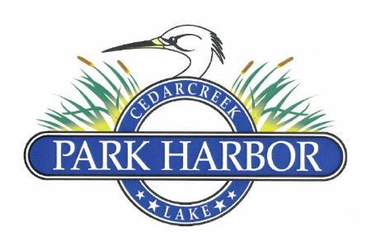

18 November 2023

PARK HARBOR POA BOARD OF DIRECTORS MEETING MINUTES

Charlene Mason called the meeting to order at 2:00PM.

Directors present were: Charlene Mason, Elaine Henley, Roddy Cummins, Randy Delana, David Gould, David Prevost and Eddie Miller.

Results of the 11.18.23 Board of Directors election were ratified.

New 2024 Board of Directors Officers were elected: Charlene Mason - President / Elaine Henley – Vice President / Roddy Cummins – Treasurer / Eddie Miller – Secretary.

Results of the 6th Amended and Restated Conditions, Covenants and Restrictions election were ratified, and Eddie was instructed to file the new CCRs with the Henderson County Clerk’s office.

Roddy led the Board in the review and discussion of the following items:

* The proposed 2024 POA budget was presented and after discussion, this budget was passed.
* A review of the POA’s liability and D&O insurance policies was presented and discussed.
* Certain expenses of the POA were discussed.
  + First, a wheelchair ramp was constructed for a resident and paid for by the POA in lieu of customary flowers sent by the POA for hospitalizations. This expense was ratified by the board.
  + Secondly, the Board clarified the type of equipment included in our existing landscape rental arrangement. After discussion, the Board (with Randy Delana abstaining from voting and discussion) approved the use of chainsaws, trimmers, and sprayers (in addition to lawnmowers) within the $25 per hour category. The Board also ratified any payment of previous expenses that included this expanded equipment list.
* The Board approved Charlene Mason and Roddy Cummins as approved signatures and the removal of Dan Prather on the POA checking account at Prosperity Bank.

The Board discussed legislative updates and new regulations to become effective in 2024.

The date for the next Board meeting was set for 2.10.24 at 10:00AM

There being no further business, Charlene adjourned the meeting.