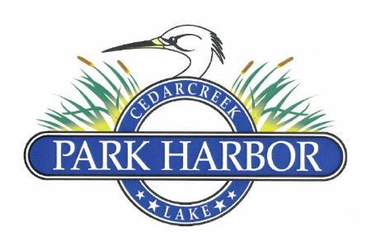

10 February 23024

PARK HARBOR POA BOARD OF DIRECTORS COORDINATION MEETING MINUTES

Charlene called the meeting to order at 10:00AM

Directors present were: Charlene Mason, Elaine Henley, Roddy Cummins, Randy Delana, David Gould, David Prevost and Eddie Miller

The Board unanimously approved the minutes for the 11.18.23 Annual POA Meeting

The Board unanimously approved the minutes for the 11.18.23 Board of Directors Meeting

Roddy presented the Treasurer’s report on the monthly financials and Member dues. These reports were approved by the Board

Eddie presented updates on the following POA projects:

1. Street sign project – cost estimate of $1,000 was approved in 2024 budget and work is scheduled to be completed Q1 2024
2. ARC & Henderson County application changes – the Board reviewed and discussed the changes and they were approved to be included on the POA website
3. A resolution thanking Dan Prather for his service was discussed then Roddy presented a draft which was approved and signed by the Board with instructions to be presented to Dan
4. The plans for the cover over the POA mail boxes was reviewed and is scheduled to be completed by the end of Q1, 2024
5. Reviewed the proposal from Do It Now Junk Removal to provide a trash removal day for the POA. It was decided that the bid was too high and a DIY solution is to be explored.
6. A bid was reviewed and approved from 4W Excavation LLC for the following drainage work 1) Survey, regrade and reshape all POA road bar ditches, 2) all existing culverts will be reshaped and cleaned out, 3) install either 12” or 15” culverts at Member cost as needed, 4) provide necessary rock to control erosion, 5) contact 411 for location of underground utilities prior to any work being performed – this project was covered in the 2024 budget

Chris Nichols presented his new replat request which was approved by the Board

Chris Nichols requested a temporary waiver for a third pet which was approved by the Board

Executive Session

Next Board of Directors meeting was scheduled for May 19, 2024 at 4:00PM

Charlene adjourned the meeting at 11.25 AM