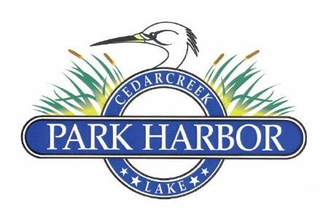

19 May 2024

PARK HARBOR POA BOARD OF DIRECTORS COORDINATION MEETING MINUTES

Elaine Henley called the meeting to order at 4:02 PM

Directors present were: Elaine Henley, Roddy Cummins, Randy Delana, David Gould, David Prevost and Eddie Miller

The Board unanimously approved the minutes for the 2.10.24 Board of Directors Meeting

Roddy presented the Treasurer’s report, which included the following items:

1. A review of the financial reports as of May 16, 2024. These reports were approved by the Board
2. A briefing on the new Corporate Transparency Act (CTA) requirements. Filing for compliance to the CTA will be filed with the federal government prior to year end
3. A discussion advising the Board that all Federal and State regulatory filings have been made for 2024
4. A report from the Financial Review Committee summarizing their process and conclusions related to the Committee’s 2023 review of the POA’s financial books and records and the POA’s overall financial administration. The 2023 Financial Review Committee members included Chris Nichols, Chad Ramsey and David Prevost. The Committee’s report outlined the processes created for the review and the scope of work performed, which included the reconciliation of cash, confirmation of all projected and required revenues, the review of all expenses, management contracts, insurance policies, compliance requirements (specific to tax filings and website requirements) and operating guidelines as set forth in the POA Bylaws. The report included recommendations observed by the Committee, and the Committee’s conclusion that in their opinion the POA’s financial statements present fairly the financial condition of the POA as of December 31, 2023 and that the financial statements are free of any material misstatement whether due to error or fraud.

Roddy/Eddie expressed the need for written policies documenting POA fine and fees. They will have a proposal at the next board meeting.

Mike Serement’s parking waiver request was approved for 90 days

Sherry Lane’s request for driveway and drainage improvements was summitted to the ARC for their review and recommendations

Greg Mason’s request to purchase a unplotted road right of way was discussed. Eddie has reached out to Precinct 2, Henderson County Commissioner, Scott Tulley, and is waiting on his direction on how to proceed.

The damage to the second gate by Steven Rollins was discussed and it was agreed that Charlene would request the Rollins’ to pay the estimated $2,250.00 repair cost.

Multiple loose dog complaints were discussed with David Gould who indicated that he would handle the matter

It was discussed the need for an active safety committee

Eddie was asked by the board to make sure the Sherriff’s department had the entry gate codes

Eddie was asked to get bids on a “siren opener” on the second gate

Eddie/Roddy reviewed the revised drainage project bid of $6,300 which was approved by the Board. They also discussed cost estimates related to future improvements to the approach of the first entry gate (Park Harbor Dr.) from the county road

The next board meeting date was set for Sunday, July 21 at 3:00 via conference call

There being no further business, Elaine adjourned the meeting at 5:20 PM