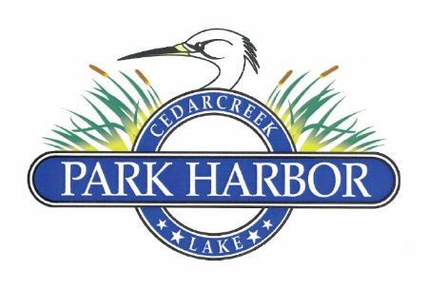

21 July 2024

PARK HARBOR POA BOARD OF DIRECTORS MEETING MINUTES

Charlene called the meeting to order at 3:05PM

Eddie gave the roll call and the following Board members were present. - Mason, Miller, Cummins, Delana, Gould, and Henley

The minutes from the last Board meeting were reviewed and approved unanimously.

Roddy presented the Treasurer’s June 2024 Balance Sheet & Income Statement. After discussion these items were approved unanimously.

Roddy suggested that the Board approve a payment to Jamie Castillo and Randy Delana for the additional work they did after the Memorial Day tornado cleanup for 4 hours ($200). Jaime’s payment will be in the form of a $100 credit to his POA balance and $100 check. After discussion, the Board unanimously approved the payments.

Roddy and Eddie reviewed the new Enforcement and Fines Policy. After discussion, the Board unanimously approved this Policy and Eddie was instructed to have it recorded at Henderson County and placed on the POA website.

Eddie presented the Mason’s request to purchase the old POA road right of way adjacent to their property. Eddie relayed his conversations with the County Commissioner and the County Attorney, and the Board asked him to contact the property owner on the other side of the right of way to determine his interest in splitting the property with the Masons.

Charlene indicated that she would follow-up with the Rollins family regarding the unpaid gate repair cost invoice.

Eddie said that Jim Barrett was ready to start the mailbox cover project with the pre-approved budget of $1,000.00. The Board unanimously agreed to begin the project.

Eddie asked if a construction extension was necessary for Mary Cunningham’s remodel and the Board asked this be passed on to the ARC.

Eddie gave an update on the pending drainage project incl. the front entrance pipe replacement. Charlene, Roddy, Randy, Eddie and Jim Barrett met with Blake Weaver and walked the project on Friday, Aug. 2nd. Blake will get an updated bid back us with a proposed start the week of Aug. 12th.

Eddie asked if anyone wanted to order Park Harbor T-Shirts to sale. The Board asked him to research pricing and present data at next meeting.

Eddie presented Muddy Moxley’s written request effecting the upcoming Serement building project. Eddie will pass this document along on to ARC.

Roddy gave a report on the Tim Randolph infraction and agreed to a personal visit if situation was not rectified.

Charlene set the date for the upcoming annual POA Member’s meeting for November 16, 2024

Charlene set the date of the next Board meeting via conference call for Sunday, Aug. 25th @ 3:00PM

Charlene adjourned meeting at 4:44PM