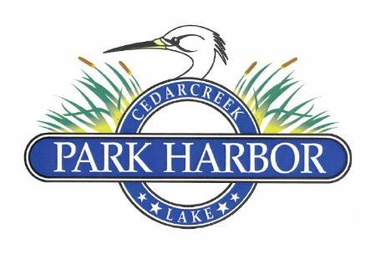

25 August 2024

PARK HARBOR POA BOARD OF DIRECTORS MEETING MINUTES

Charlene - called meeting to order at 3:05PM

Eddie – roll call - present were Miller, Cummins, Henley, Delana, Mason

Eddie – approve minutes from last board meeting – unanimously approved

Roddy – Treasurer’s report (July ’24 Balance Sheet & Income Statement) – during executive session review, the Balance Sheet & Income Stmt. were unanimously approved

Roddy – approve ARC charter language change – after discussion language was approved and Eddie was directed to record with County and post on the POA website

Eddie – Enforcement and Fines Policy update – new policy has been recorded with the County and posted on the POA website

Eddie – after discussion it was agreed to raise trailer parking spaces from $20 to $50 per year beginning 2025

Eddie – after discussion the decision was made to replace the old teeter-toter at the park

Eddie – spoke w/ Lakeshore Utility twice re: mowing pump house lot & checking leak on park property

Eddie – drainage plan from Jeff Walters has been requested by Roddy and was promised to be delivered within approx. two weeks

Eddie – we will put up the construction entrance sign at the first entrance and the exit sign at the second entrance

Eddie – Mason’s request to purchase old road right of way update – Board approved a 10-year lease for $100 to the Masons and the Parkers. Next sept will be to have the Members vote at the annual meeting.

Charlene - Second gate repair damage by Rollins update - POA tax ID number was provided to the Rollins

Eddie – Board discussed the 4W drainage project bid in the amount of $17,500 and approved

Eddie – Blake Weaver (4W) requested property to use as a staging area for rock storage and Eddie has agreed to let him use one of his lots

Charlene – will appoint election committee & nomination committee prior to our 9/22/24 Board meeting

Charlene – next Board meeting date set for Sept. 22nd 3:30 PM at Mason’s residence

Charlene – meeting adjourned @ 4:45PM